Specialist Test 2 Notes – Year 11 2023

By Ajay Bisnath

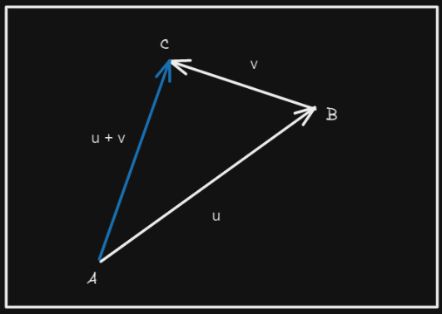**Vectors:**

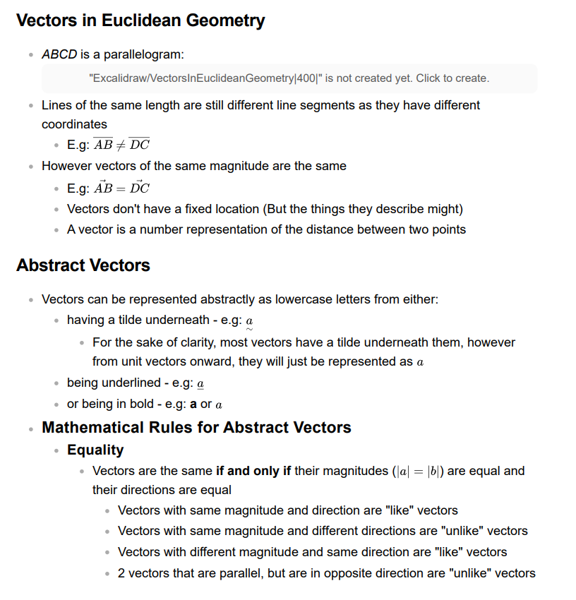



**If you solve something with ClassPad put:**

equation (e.g: x + 5 = 12) $∴ answer$ 
 (e.g: $∴$ x = 7)